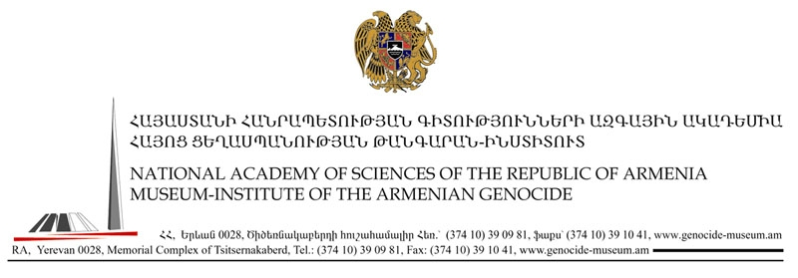
Press Release
18-May-2007
For Immediate Release
Hayk Demoyan, Director Of The Armenian Genocide Museum & Institute (AGMI), Wins Top Honors At International Social Sciences Competition

Urbat Press Club, Yerevan, Armenia, 18-May-2007--At the CIS social scientists’ General History competition themed: the end of the 20th century and beginning of the 21st century, 86 qualified scientific works were presented. The Russian Federation’s State Archives Director, Sergei Mironenko headed a jury of peers who chose eight finalists, two of whom were Armenian, Hayk Demoyan, Ph.D and Arsen Hakobyan, Ph.D. The grand prize was awarded to Hayk Demoyan for his monograph entitled: Turkey and Karabakh Conflict: A Historical & Comparative Analysis.” Arsen Hakobyan’s work on Tat-Speaking Armenians won third place.
Demoyan’s work primarily used neutral sources to demonstrate Turkey’s culpability in aiding and supporting Azerbaijan’s political, military and economic aggressive policies against Nagorno-Karabakh and the Republic of Armenia. The main conclusions of the monograph placed Turkey’s at the epicenter of the Karabakh conflict vis-a-vis its comprehensive support of Azerbaijan. It also illustrates how Turkey actively lobbied various international organizations in order execute a policy of hostile pressure on the Republic of Armenia and also confirmed that Azerbaijan recruited foreign Islamic mercenaries to fight against the civilian population of Nagorno-Karabakh.

